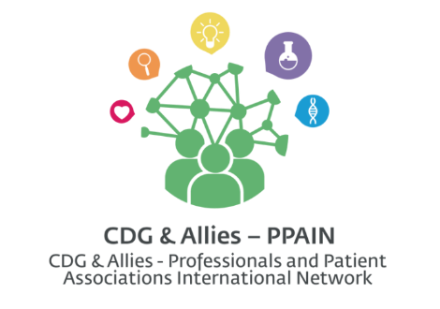
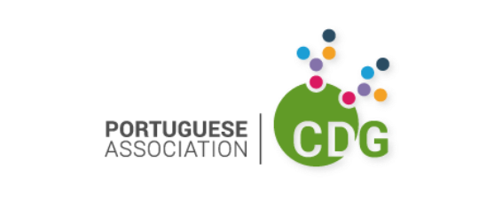

Title: Eleonora Passeri – The importance of Communication!

My name is Sandra Brasil and I’m a CDG Patient Community Liaison at the Portuguese Association for CDG (APCDG). Today, I have the pleasure to talk with Eleonora Passeri, a PhD in Neuroscience that has dedicated her last years to Public Awareness in the field of Rare Disorders. Welcome Eleonora—it is real delight to have you at CDG One-to-One!

Part 1: Communication for the Rare Community

Q1: Sandra Brasil: Eleonora, you have a PhD in Neuroscience and you have worked as a postdoc at prestigious institutes such as Johns Hopkins Hospital, The Georgetown University and the McLean Hospital in Boston. What drove you to the Communication field?
Eleonora Passeri: Hi Sandra, firstly let me thank you, Vanessa, and all the CDG community for having me here, it is a real pleasure for me. I have always been passionate about science and how our brain and body work, so I loved my bench research time and I have learned a lot from that experience. What moved me into “alternative” directions was my personal need to help patients and families in a different way. I wanted to get in touch with them, listen to them, and understand how research could have been better addressed in a more patient-centered approach. Communication was, and still is the key, to make this shift.
Q2: Sandra Brasil: You have developed an international cross-disciplinary network between artists, scientists and patient groups on social media. What is the main goal of this network?
Eleonora Passeri: Lately, I have added also another type of “category” to this list: The “supporters” such as friends and cute mascots! To get back to your question, the main goal of this “movement” is trigger a new era of progress, a second Renaissance, thanks to a novel combination of art and science to fill the existing patient-centric gaps by bridging together different stakeholders. Art is a powerful tool, since we are naturally attracted by beauty.
Q3: Sandra Brasil: To you what are the 3 major challenges in creating awareness on social media for rare disorders?
Eleonora Passeri: Based on my experience, I would say: 1) going from virtual to real to establish trustful relationships with people, 2) being unique and create an original niche where share your own contents or those of your own collaborators, 3) and being constant over time –which is very demanding!-. But also, reach out to people, talk with them, being honest, and share your ideas and vision. Being willing to try something new that no one has ever done before and keep testing new strategies or approaches. Failures are part of the game, but keep studying your “followers”, connect with them, show them you are there for them, and things will work out at the end. Believe in your project!
Q4: Sandra Brasil: In today’s world it’s impossible to escape social media. What would be your advice to a patient association on how to take advantage of social media to spread awareness?
Eleonora Passeri: Indeed, we can not escape from socials in our days, but socials are a tool not the aim, so we need to use them smartly. Connect with your community first, get them involved on your projects, organize your team and resources, if you have produced materials and contents already, study them more accurately and find a new strategy to tell your story. This is the first step: 1) organize your own community, 2) create a team, 3) and program your work for the next 6 months at least, better a year. Once this is done, you can move ahead to the second step and connect with other patient groups –same rare disease or different ones-, advocates, and other stakeholders to establish a solid international network intra- and inter- rare diseases.
Q5: Sandra Brasil: You have been collaborating with APCDG to establish a communication plan on social media and now you will have the opportunity to became part of our network as a post doc. How do you feel about this opportunity?
Eleonora Passeri: I am very exited about this new step in my social media and consulting journey! To me all I do on Rare Diseases and with patients is personal, so I am really honored and happy to help out the CDG community as advocate and scientist. What makes me really enthusiastic is the possibility of impacting society and research with a real patient-centric strategy, show people as well as the scientific and policy maker communities that patients and scientists can work together as peers to do some innovative and real original scientific research on a translational and clinical level.
Q6: Sandra Brasil: What is the favorite aspect of your work?
Eleonora Passeri: I might have more than one actually: Creativity, network, and freedom! I love being able to use my creativity for Rare Special Powers art and scientific projects and come up with new ideas and plans. I enjoy a lot talk or chat with people and connect with them; I brainstorm with patients and moms about art and science, to me they are “Experts by Experience”, but I also like to chat with other people…researchers, medical doctors, artists, art historians, journalists, and “common people”, because everyone has a story to tell and something to teach me. So, I talk a lot, but I also love listening to others when they have something interesting to say. I love being free to think, try, and sometime even fail –it is part of the game-. When I was “young” I thought I needed to think “outside the box” to really apply my “critical thinking as scientist”, now I came to the conclusion that there is no box at all, so I just let my brain think freely.
Q7: Sandra Brasil: What part of your work so far do you think is most impactful?
Eleonora Passeri: You might think do awareness, so share info and contents about Rare Diseases. Truth is the most impacting part of what I do, the one that pushes and motivates me everyday is getting inside the families of patients I collaborate with, get into their lives, and being part of them. I believe it is a real privilege and I treasure every memory and every detail. Talking with patients and moms, made me a better scientist, advocate, and communicator, thanks to them I could really sharp my critical thinking and increase my empathy towards humanity. I have learned from them that every life counts, that behind a disease there is always a person with his/her story and family, and that you can change things if you really want.

Part 2: Personal life and hobbies
Q8: Sandra Brasil: Tell me a little bit of what you like to do when you aren't working.
Eleonora Passeri: I might say that somehow I work all day and all time, 24/7 or at the same time, I do not work at all, why? A quote from an unknown person says “choose a job you love and you will never have to work one day in your life”, well…I believe this person was right. I do what love and I love what I do, so it is not a real “work” for me, it is part of me, it is who I am. However, when I have some free time, I love going to museums, visit small little towns and villages around where I live –in Italian we called them “borghi”- to discover amazing pieces of art left by previous generations and still unknown in most cases. I love reading books about history, art, science, novels, poems, classics, economy, politics, biographies…every book is a new journey across time and space. I love classical music, opera, and ballet and when I get the chance I go to theater. I watch very little TV, but sometime I found –few- good programs, movies, and cartoons! I also write fairy tails…but it has been a while since the last one, I have very little time lately.
Q9: Sandra Brasil: What’s your secret to find a good balance between your busy work and personal life?
Eleonora Passeri: Honestly, I do not know if I really have a good balance based on my previous answer, but I have learned to take some time off for me to do the things I like. I would say that a calendar, an agenda, and a to do list help me to organize my time and find some free time for my self and for thinking about my next project.

